**Description:**

This is a color coding tool used for AAG bugs/feature request artifacts. This tool will use an excel file that has been exported from team forge and filter through the dates and mandatory cells that are required by each member to be completed depending on the dates. If the specified artifact is clear it will be highlighted in green. If the artifact is bad then it will be highlighted in red.

**Requirements:**

The following are the required column names are required in the export for the tool to work successfully:

1. Actual Coding
2. Actual Design
3. Actual Finish
4. Actual Start
5. Actual testing
6. Artifact ID
7. Assigned To
8. Code Review Comments
9. Code Review Passed
10. Code Reviewer
11. Estimated Coding
12. Estimated Design
13. Estimated Testing
14. Planned Finish
15. Planned Start
16. Status
17. System Test Required
18. Test Tools/Description
19. Tested By
20. Title
21. Unit Test Passes
22. Unit Test

Without these column names the tool will not work successfully

**Instructions:**

Export the excel file with the required column names

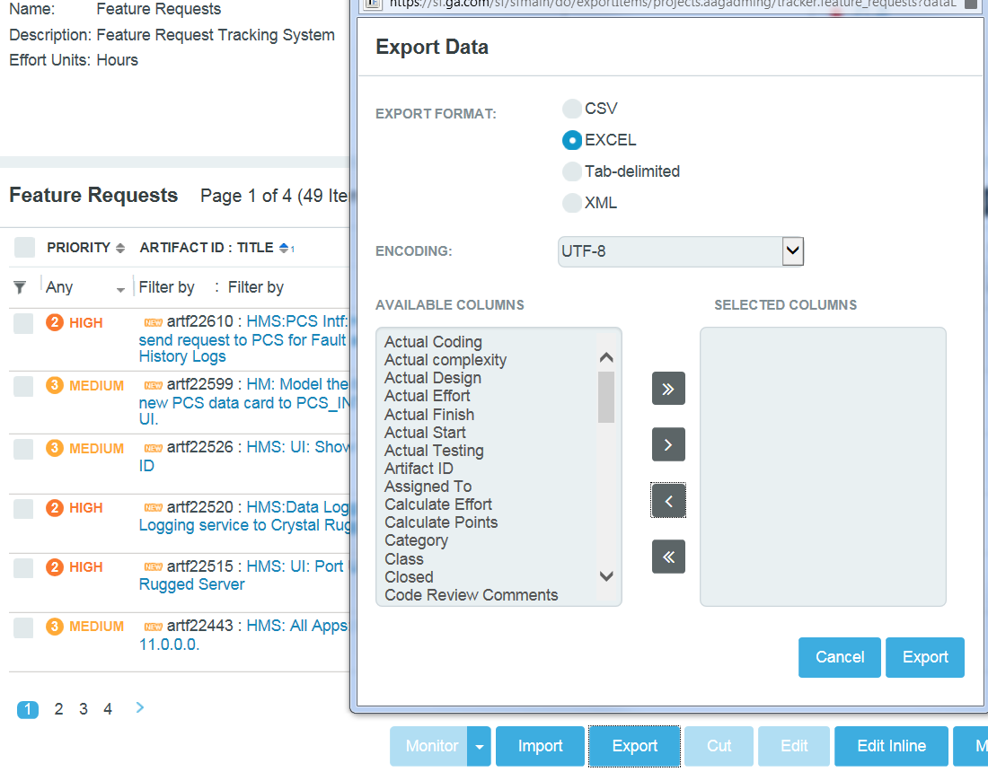

Open the artifact filtering tool

Click the “Check File” button to begin conversion of the file.

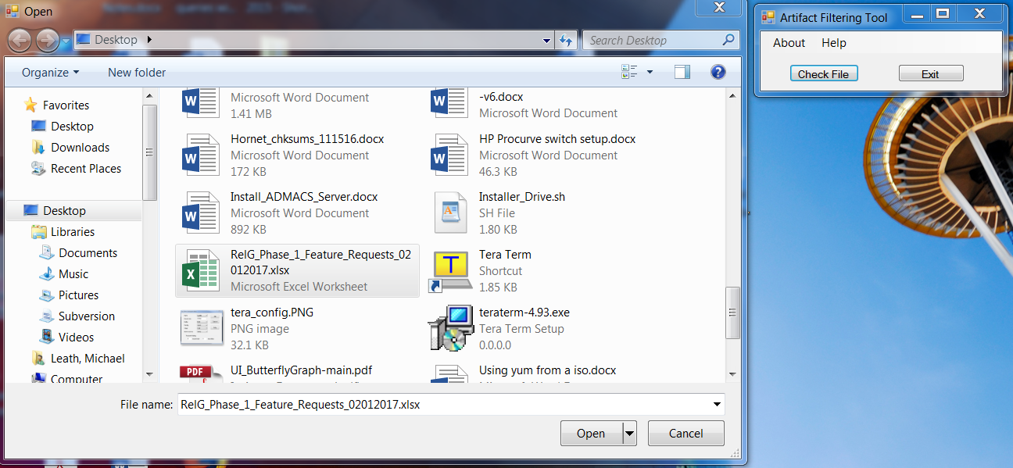

The application will let you know when it completes. Then the two options is to repeat the process for another file or use the close button to close the application.